Journal of Food Science

About the Journal:
The Journal of Food Science is an international peer-reviewed journal that provides a platform for the dissemination of innovative research and scientific advancements across the diverse disciplines of food science, nutrition, and food technology. The journal publishes high-quality original research articles, comprehensive reviews, short communications, and emerging perspectives that contribute to improving food quality, safety, sustainability, and human health. Its scope encompasses food chemistry, food microbiology, food engineering, food processing, biotechnology, sensory science, nutrition, functional foods, food packaging, toxicology, and regulatory science. By encouraging interdisciplinary collaboration, the journal seeks to advance scientific knowledge that addresses current and future challenges within the global food system.
As food systems continue to evolve in response to population growth, climate change, and changing consumer expectations, the Journal of Food Science highlights research that promotes sustainable innovation and practical solutions for the food industry. The journal welcomes studies on novel food ingredients, sustainable processing technologies, precision nutrition, bioactive compounds, alternative proteins, food waste valorization, smart packaging, supply chain resilience, and advanced approaches to food safety and quality assurance. By connecting researchers, industry experts, and policymakers, the journal fosters the translation of scientific discoveries into real-world applications that enhance public health, strengthen food security, and support the development of resilient and sustainable food systems worldwide.

Latest News:
Personalized Nutrition Based on the Human Microbiome:-
The human microbiome continues to revolutionize nutritional science in 2026 by providing new insights into how gut microorganisms influence digestion, immunity, metabolism, and overall health. Researchers are developing personalized dietary recommendations based on individual microbiome profiles to improve the prevention and management of obesity, diabetes, inflammatory bowel disease, and cardiovascular disorders. Advances in microbiome research are also driving the development of targeted probiotics, prebiotics, and functional foods designed to restore microbial balance and promote long-term health, marking a significant step toward precision nutrition.
.

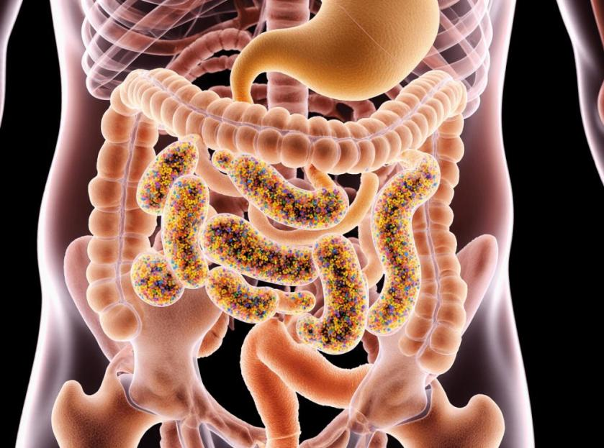

Precision Fermentation: The Future of Sustainable Food Production:-
Precision fermentation has emerged as a breakthrough technology in 2026, enabling microorganisms such as yeast and fungi to produce high-value food ingredients including dairy proteins, enzymes, vitamins, and specialty fats without relying on conventional livestock farming. This innovative approach significantly reduces land use, water consumption, and greenhouse gas emissions while maintaining product quality and nutritional value. The technology is accelerating the development of sustainable alternative proteins and functional ingredients, offering environmentally friendly solutions to meet the growing global demand for nutritious foods.
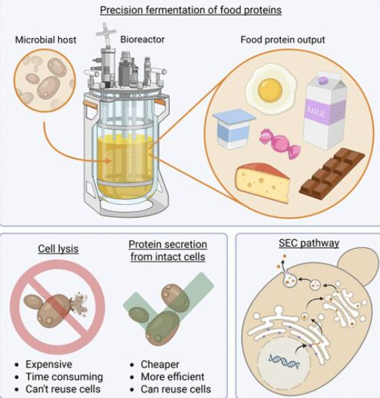

Upcycled Foods: A Sustainable Solution to Food Waste:-
In 2026, upcycled foods have become one of the fastest-growing innovations in the food industry, transforming surplus fruits, vegetables, grains, and food processing by-products into nutritious, value-added products. This approach not only reduces food waste but also conserves natural resources and lowers greenhouse gas emissions associated with food production. Manufacturers are increasingly incorporating upcycled ingredients into bakery products, beverages, snacks, and protein-rich foods, supporting a circular food economy. As governments and industries strengthen their commitment to sustainable food systems, upcycled foods are emerging as an effective strategy to enhance food security while promoting environmental sustainability.
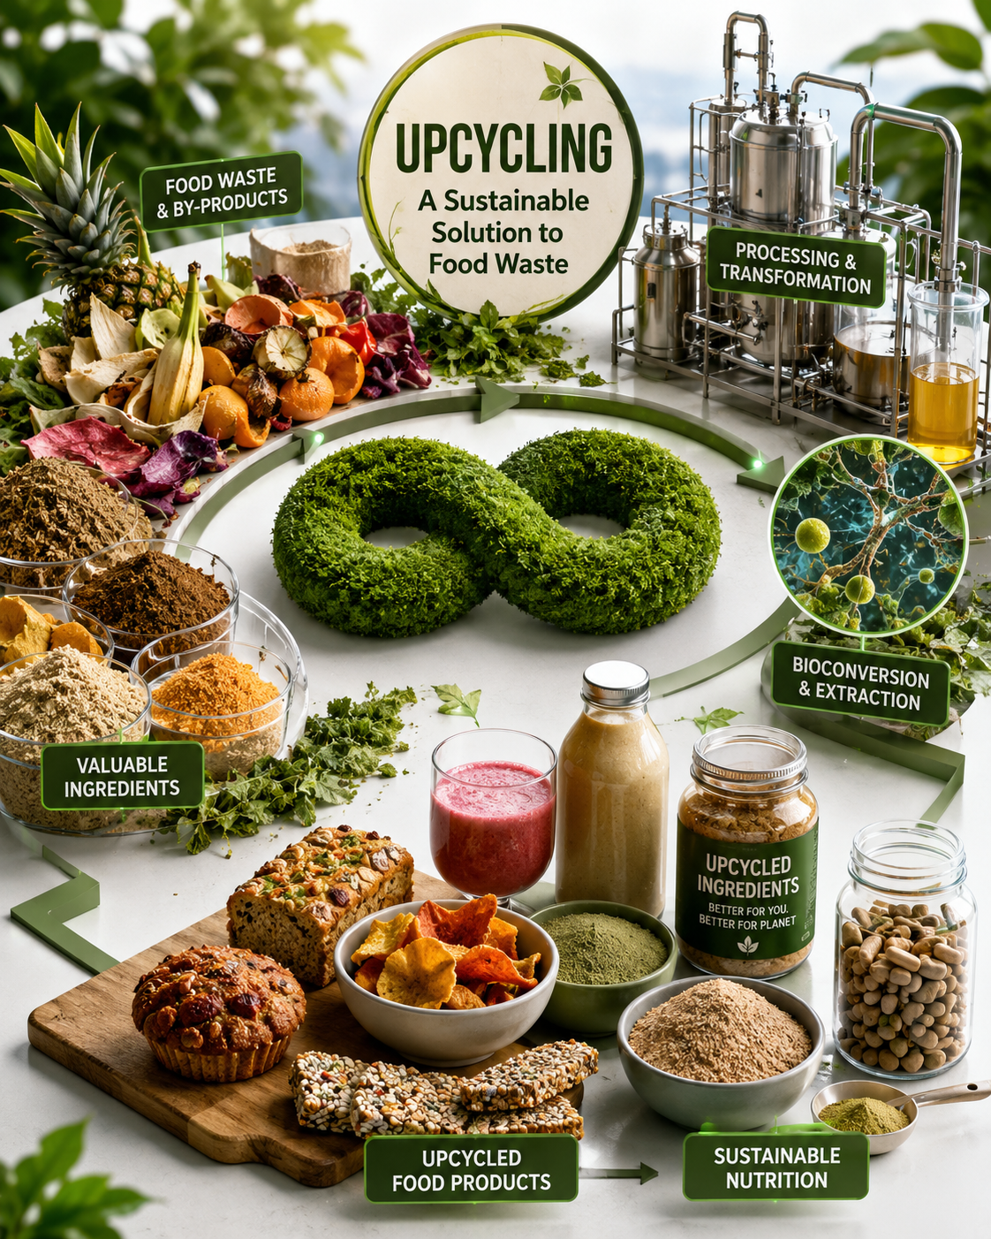

Artificial Intelligence and Smart Biosensors for Food Safety Detection:-
Ensuring food safety remains a global priority, and in 2026 artificial intelligence combined with smart biosensor technologies has significantly enhanced the detection of food contaminants and pathogens. Modern food safety systems now employ AI algorithms, Internet of Things (IoT) devices, rapid biosensors, and blockchain-enabled traceability to monitor food quality throughout the supply chain. These technologies allow for real-time identification of microbial contamination, chemical residues, allergens, and spoilage indicators, enabling faster responses to potential food safety risks. The adoption of intelligent monitoring systems not only improves regulatory compliance but also strengthens consumer confidence by increasing transparency, reducing foodborne illness outbreaks, and minimizing product recalls.

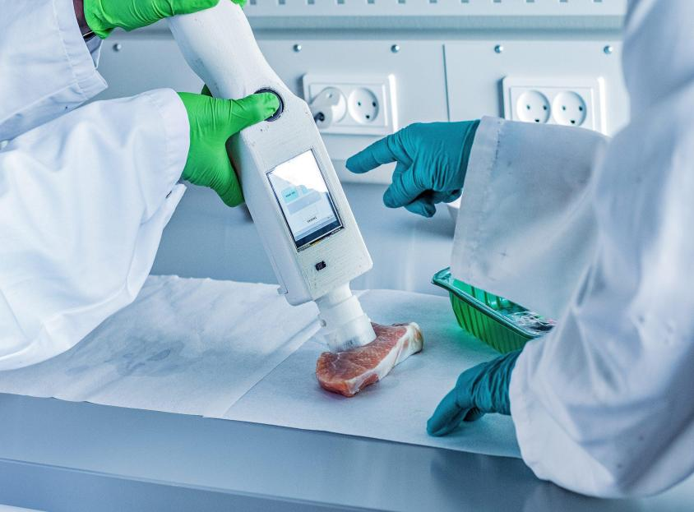

Scientific Topics:

1. Farm to Fork: Sustainable Food Production
Explores sustainable approaches to food production from agricultural practices to consumer delivery. Emphasizes environmentally responsible farming, resource conservation, and resilient food supply chains to ensure global food security and sustainable development.
2. Food Waste Tackling
Focuses on innovative strategies to reduce food loss and waste throughout the food supply chain. Highlights food waste valorization, upcycling technologies, and circular economy solutions that promote sustainability and resource efficiency.
3. The Human Microbiome
Examines the role of the human microbiome in nutrition, metabolism, immunity, and overall health. Covers recent advances in microbiome research, personalized nutrition, probiotics, and functional dietary interventions.
4. Food Safety & Regulatory Science
Addresses scientific principles and regulatory frameworks that ensure food quality and consumer safety. Includes risk assessment, food legislation, quality assurance, contaminant monitoring, and international food safety standards.
5. Food Production with Agricultural and Plant Biotechnology
Explores the application of biotechnology to enhance crop productivity, nutritional quality, and environmental sustainability. Covers genetic improvement, molecular breeding, genome editing, and innovative agricultural technologies.
6. Nutrition for Health and Sustainability
Highlights the relationship between balanced nutrition, public health, and environmental sustainability. Discusses sustainable dietary patterns, nutritional interventions, and strategies for promoting healthier lifestyles.
7. Technologies for Sustainable Farming Systems
Focuses on innovative technologies that improve agricultural productivity while conserving natural resources. Covers precision agriculture, smart farming, climate-resilient practices, and digital solutions for sustainable food production.
8. Emerging Technologies for Detection of Food Safety
Explores advanced technologies for the rapid detection of foodborne pathogens, contaminants, and adulterants. Highlights biosensors, nanotechnology, molecular diagnostics, and intelligent monitoring systems that enhance food safety.
9. Sensory & Consumer Science
Examines consumer perception, food preferences, and sensory evaluation techniques used in product development. Focuses on taste, aroma, texture, appearance, and consumer behavior to improve food acceptance and market success.
10. Food Engineering and Bioavailability
Covers engineering innovations that improve food processing, preservation, and nutrient delivery. Explores technologies that enhance the bioavailability, stability, and functionality of essential nutrients and bioactive compounds.
11. Traditional & Future Foods
Discusses the preservation of traditional food systems alongside the development of future food innovations. Includes alternative proteins, fermented foods, indigenous foods, and sustainable dietary solutions for future generations.
12. Chemistry and Biochemistry of Foods
Focuses on the chemical composition and biochemical processes that influence food quality, nutrition, and functionality. Covers food components, enzymatic reactions, antioxidants, and molecular interactions during processing and storage.
13. Functional Foods, Nutrition, Nutraceuticals & Bioactives
Explores foods and bioactive compounds that provide health benefits beyond basic nutrition. Highlights nutraceuticals, probiotics, phytochemicals, functional ingredients, and their role in disease prevention and health promotion.
14. Food and Chemical Toxicology
Examines the safety evaluation of food contaminants, additives, natural toxins, and chemical residues. Covers toxicological assessment, exposure analysis, risk management, and regulatory approaches to protect consumer health.
15. Novel Processing and Packaging Technologies
Highlights innovative food processing methods and advanced packaging systems that improve product quality, safety, and shelf life. Covers sustainable packaging materials, non-thermal processing, smart packaging, and preservation technologies.
16. Food and Nutritional Science
Explores the scientific relationship between food composition, nutrition, and human health. Covers dietary assessment, nutrient metabolism, public health nutrition, and evidence-based approaches to improving nutritional well-being.
Editorial in Chief:
Oliver Micke
Department of Radiation Therapy and Radiation Oncology, Franziskus Hospital,Germany
Biography:
Head of the department of radiotherapy and radiation oncology, and clinical director of the Franziskus Hospital Bielefeld, Germany, teaching hospital of the Hannover Medical School (MHH). He is president of the German Magnesium Society and chairman of the German Working Group “Trace Elements and Electrolytes in Radiation Oncology” and associate editor of “Trace Elements and Electrolytes”- Official Organ of the "Society of Magnesium Research", Germany, and German Working Group “Trace Elements and Electrolytes in Radiation Oncology” AKTE, Germany. He authored more than 270 publications in peer reviewed scientific journals and has been invited as speaker at national and international meetings.

8 Articles are attached herewith…

